**Ideation Phase**

**Define the Problem Statements**

|  |  |
| --- | --- |
| Date | 16 June 2025 |
| Team ID | LTVIP2025TMID41759 |
| Project Name | ResolveNow |
| Maximum Marks | 2 Marks |

**Customer Problem Statement:**

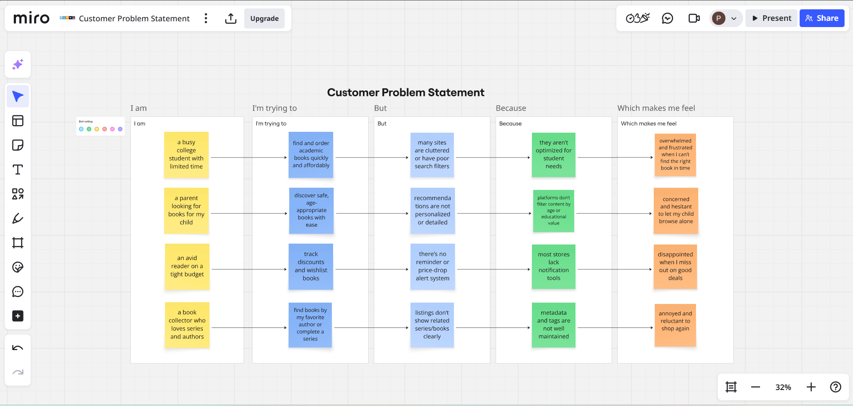

|  |  |  |  |  |  |
| --- | --- | --- | --- | --- | --- |
| **PS** | **I am (Customer)** | **I’m trying to** | **But** | **Because** | **Which makes me feel** |
| PS-1 | a college student dealing with infrastructure issues on campus | submit a complaint easily and see quick results | the complaint process is slow or unclear | there's no transparent tracking or updates | frustrated and unheard about recurring problems |
| PS-2 | a working professional in a public institution | report technical malfunctions without leaving my desk | I don’t know who’s responsible | there’s no centralized system for filing or following up | disengaged and forced to tolerate inefficiencies |
| PS-3 | a community resident dealing with civic problems | file complaints like garbage collection or water leakage | my past complaints were ignored or unresolved | there’s no feedback mechanism or response accountability | discouraged and hesitant to complain again |
| PS-4 | an admin trying to manage city-wide complaints | assign and resolve issues systematically | data is scattered and complaints aren’t categorized properly | we lack tools to filter, prioritize, and track complaints efficiently | overwhelmed and reactive instead of proactive |